LAB 3

1. chmod u+x chap1.txt



1. chmod a+x add.c



1. chmod u-x,g+r,o+r aa.c
2. chmod u+x a.c kk.c nato myfile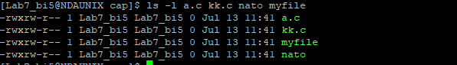
3. ls bin

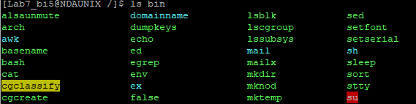

ls etc

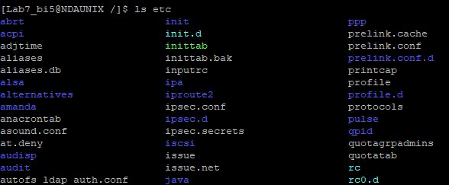

ls usr

